#5 - Delta

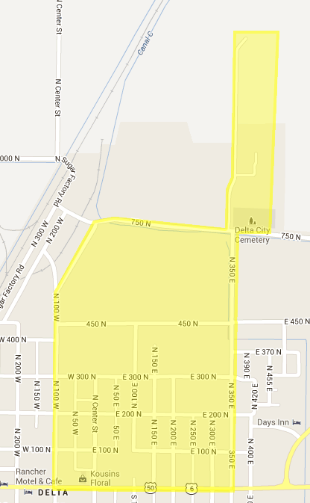
Spanish Addresses

Do Not Calls

